Auto SMEs not availing complicated DTRE benefit: Paapam
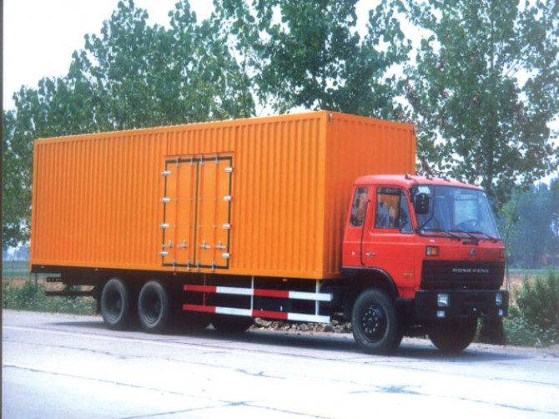
M RAFIQUE GORAYA
LAHORE: Only big exporters and large scale manufacturers are availing full benefit of duty-free raw material under Duty Tax Remission for Exports (DTRE) scheme, because SMEs can neither comply with the lengthy, complicated and cumbersome procedures nor can they import full consignment of containers.
This was stated by Pakistan Association of Automotive Parts and Accessories Manufacturers (PAAPAM) Chairman Munir Bana and Vice Chairman Usman Malik on Monday.
Taking to Business Recorder on telephone Munir Bana said that the DTRE procedure had been designed in such a manner that not a single company out of several hundred auto engineering sector units in Pakistan was benefiting from the scheme to increase the country’s export volumes.
Stressing the need for consistency in export-related policies, he urged the government to simplify the complex nature of several segments of its policy, including DTRE and Sales Tax Refund system.
If the interim government removes all the bureaucratic red tape from the DTRE scheme, making it practical and simple, exports of auto engineering sector can be enhanced manifold as production cost will be minimised by at least 15 per cent, he added.
Bana appreciated the government’s efforts to introduce such export-friendly schemes but showed reservations over implementation process of those plans, and suggested that the authorities should remove all impediments and apply the schemes in its true spirit.
Vice Chairman Usman Malik stated that around 90 percent of export-oriented auto engineering units were located in Punjab, and because that province was hit by the worst energy crisis, those units had not been in a position to avail import of duty-free raw material, with a view to avoid delay in export orders, as audit of DTRE takes up to six months.
Usman also stated that auto engineering industry was totally different from other sectors, which was very sophisticated and complex and DTRE rules couldn’t be implemented to it. So, the government, keeping in view of the complexity of the auto sector, should align the rules of DTRE as per auto industry’s requirements to give a jump start to the export of automotive parts.
He appealed to the government to also proactively deal with the ongoing energy crisis and other issues to avert industrial closures and resultant economic downturn.
He said power shortage had not only caused unrest among the businessmen but it was depriving country of two percent of much-needed GDP with an impact of Rs52 billion per annum on revenue generation and if seriousness was not shown practically, it was not the industrial production alone but all economic activities would come to a grinding halt in totality.

http://www.brecorder.com/epaper/br_458743_1716.html?title=Auto%20SMEs%20not%20availing%20complicated%20DTRE%20benefit:%20Paapam

