

PAAPAM Annual Report 2025–2026
(For AGM Circulation)

PAAPAM Annual Report 2025–2026
(For AGM Circulation)
S. No. | Category | Activity | Date(s)
1 | Meetings | - Executive Committee : 11  - PAPS 2026 Organizing : 14  - PSDC : 5  - 2–3 Wheelers : 5  - Membership : 3  - Exports & Exhibitions : 2  - Media & Publications : 5 | Dec 2025 – Jul 2026
2 | Meetings | Annual General Meeting (AGM) | 3 Dec 2025
3 | Meetings | Extraordinary General Meeting (EOGM) | 24 Feb 2026
4 | Training | MS Excel with AI – Smart Productivity | 5 Sep 2025
5 | Training | Online Training: Resource Efficiency & TVET | 31 Dec 2025
6 | Training | Smart Data Management (Excel & AI) | 11–12 Mar 2026
7 | Training | Energy Management Training (ISO 50001:2018 aligned) | 29 Apr 2026
8 | Training | Internal Training of CMS | 2026
9 | Technology & Innovation | EV Bikes Development – engagement between local vendors, EV OEMs and EDB | 2026
10 | Governance | Secretariat operations successfully audited under ISO standards | 2026
11 | Events | Launching Ceremony of PAPS 2026 | 16 Feb 2026
12 | Events | Pakistan Auto Show (PAPS 2026) | 18–20 Sep 2026
13 | Publications | PAAPAM Directory 2026 (under Mr. Razzak Ahmed’s leadership) | 1 Sep 2026
14 | Membership | PAAPAM Elections | Sep 2026
15 | Membership | PAAPAM Membership Card Issuance | Jun 2026
16 | Exhibitions | 10 PAAPAM Member Companies participated in AAPEX Show 2025, Las Vegas (TDAP subsidy PKR 9 Million) | Nov 2025
17 | Exhibitions | 7 PAAPAM Member Companies scheduled for AAPEX Show 2026, Las Vegas (TDAP subsidy PKR 6.3 Million) | Nov 2026 (planned)
18 | Export Facilitation | Advocacy with TDAP & Ministry of Commerce for simplified export procedures; recommendations on duty drawback & export finance | 2026
19 | Subsidies | PAAPAM subsidy of approx. PKR 10 Million to members at PAPS 2026 in Auto Parts Village | Sep 2026
20 | Policy Advocacy & Govt | Position papers on Auto Policy 2026–31 submitted to MoIP, Commerce Division, SIFC Secretariat; meetings with Federal Minister for Industries & Production, SAPM Haroon Akhtar Khan, Minister Ahsan Iqbal, Minister Musadik Malik, Secretary SIFC, Lt Gen Zafar Iqbal (NCMC) | Sep 2025 – Sep 2026
21 | Policy Advocacy & Govt | Inputs on National Tractor Policy with MoIP and Provincial Govts (Punjab & Sindh); coordination with Punjab Industries & Commerce Department | 2026
22 | Policy Advocacy & Govt | Counterbriefs on Used Car Import Policy submitted to MoIP, EDB, Finance Minister, and Commerce Minister | 2026
23 | Policy Advocacy & Govt | Technical counterarguments on IMF Tariff Rationalization Plans presented to MoIP, Finance Minister, and FBR | 2026
24 | International Engagement | Visit of Iranian Consulate General | 31 Jul 2026
25 | Institutional Engagement | Advisor to CM Punjab Mr. Ali Dar attended PAPS 2026 inaugural; commitment secured for PAAPAM’s audience with Deputy PM Ishaq Dar | Sep 2026
26 | Institutional Engagement | Active liaison with Lt. Gen. Sarfraz Ahmed, National Coordinator SIFC – industry concerns integrated into SIFC framework | 2026
27 | PAAPAM | PAAPAM Zonal Office Renovation | Sep 2025

Executive Committee Meetings 11 sessions held between Dec 2025 – Jul 2026, strengthening governance and decision-making.

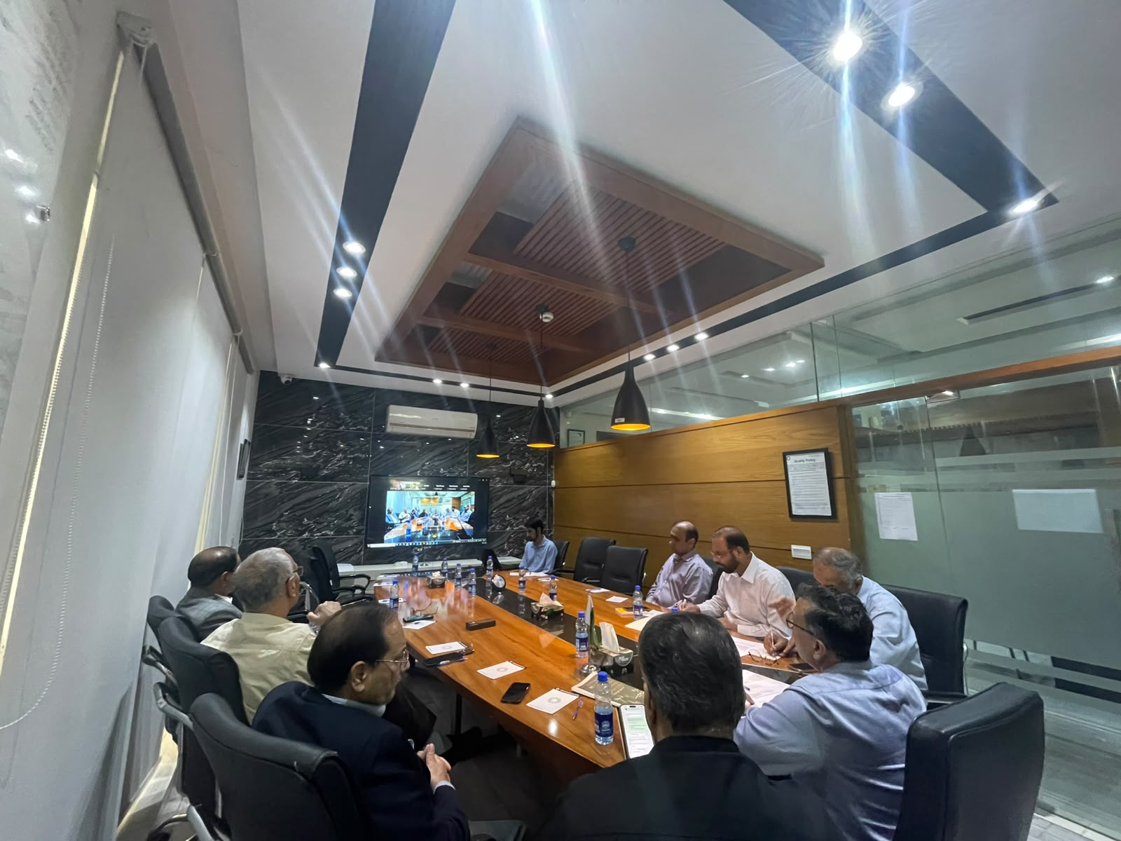
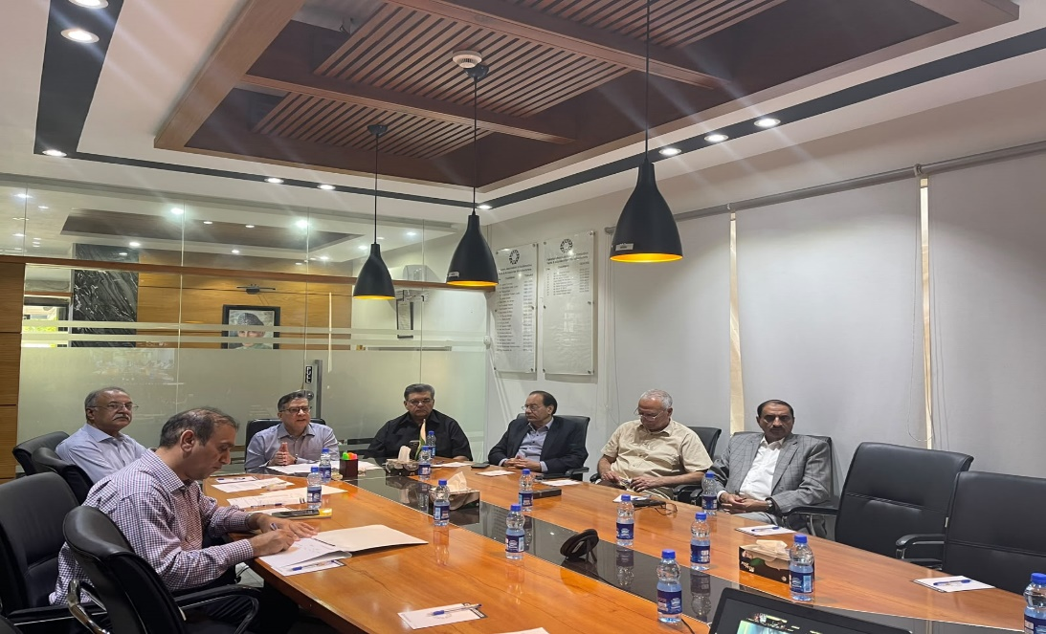

Skill Development Workshops
MS Excel with AI – Sep 2025, Karachi Interactive workshop on smart productivity tools.
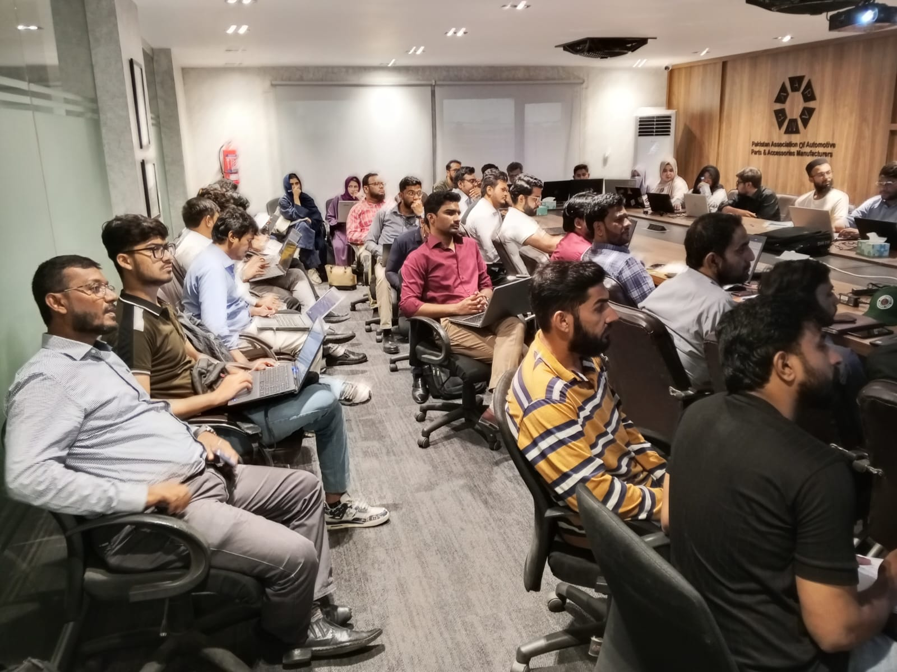
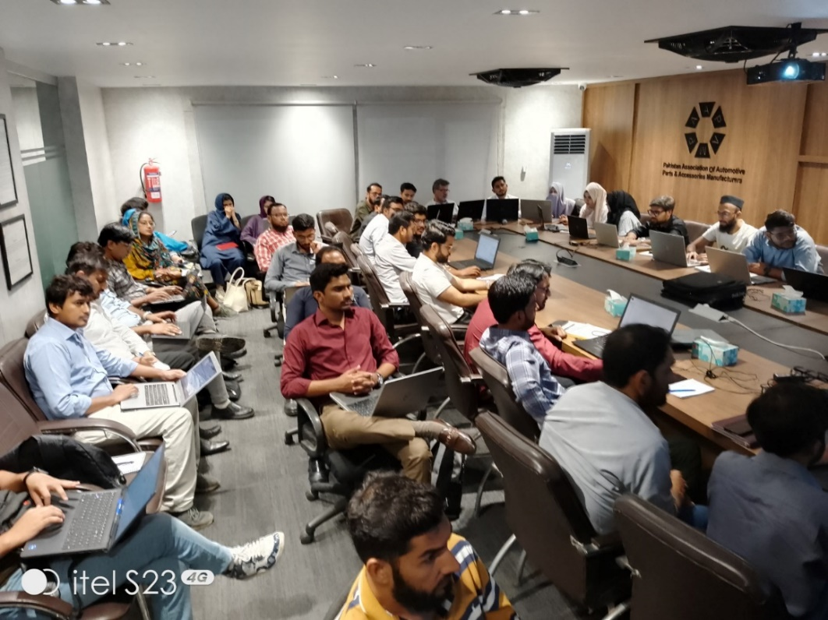

Smart Data Management – Mar 2026 (Ramadan) Enhanced analytical decision-making with Excel & AI.
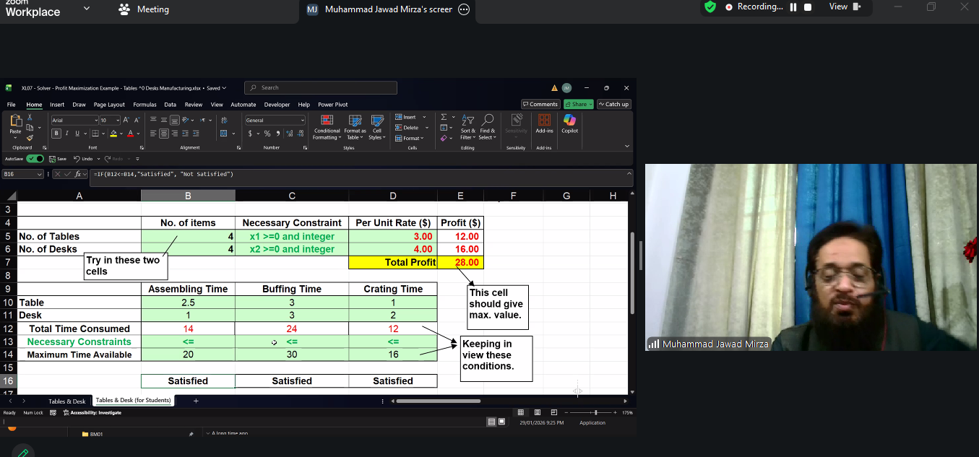

Energy Management – Apr 2026 ISO 50001:2018 aligned training for sustainable practices.
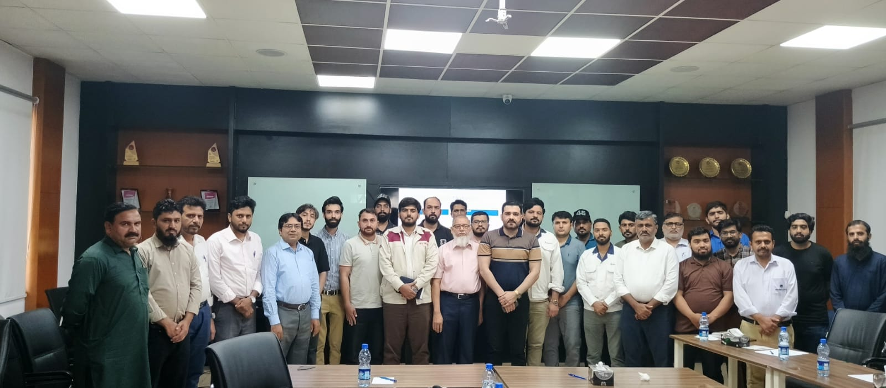
Major Events
Launching Ceremony of PAPS 2026 – Feb 2026, PC Hotel Lahore
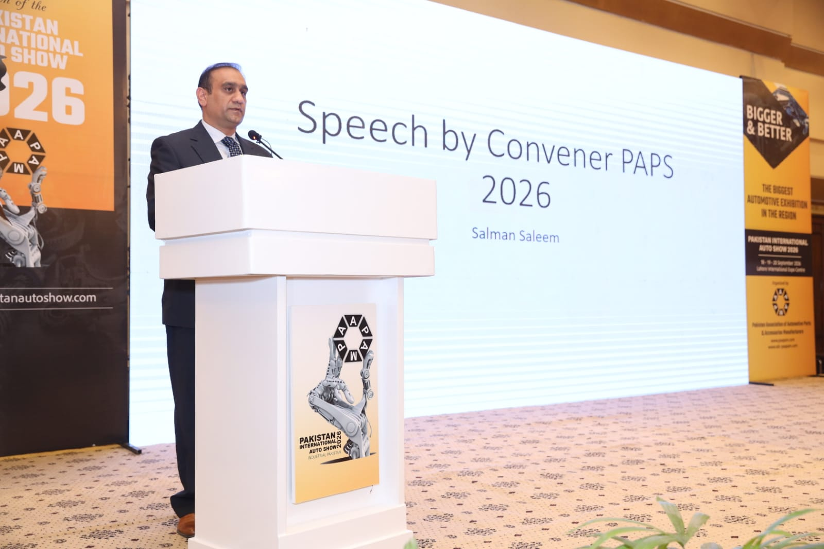
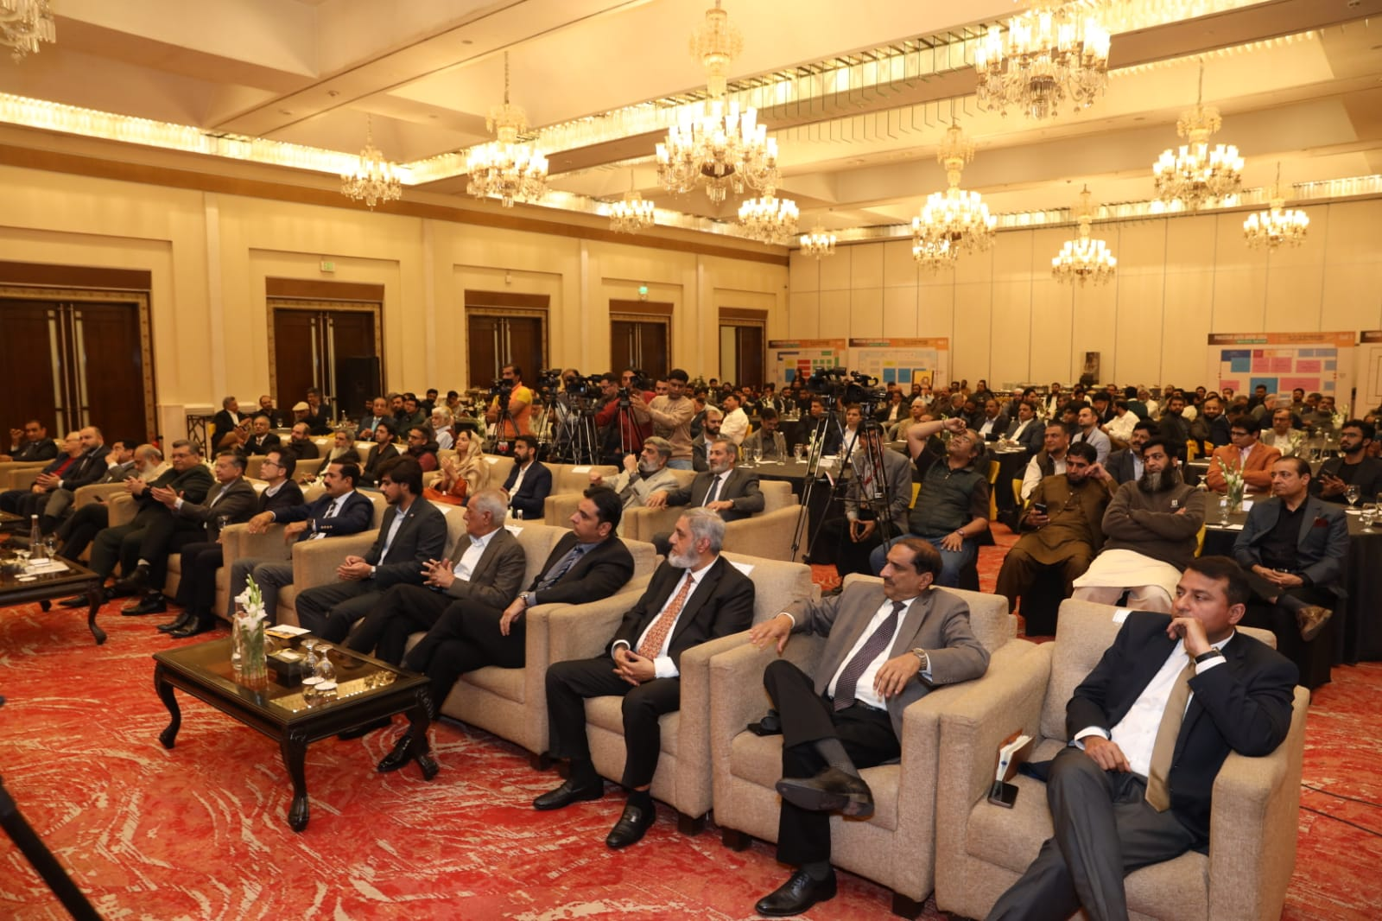

Pakistan Auto Show 2026
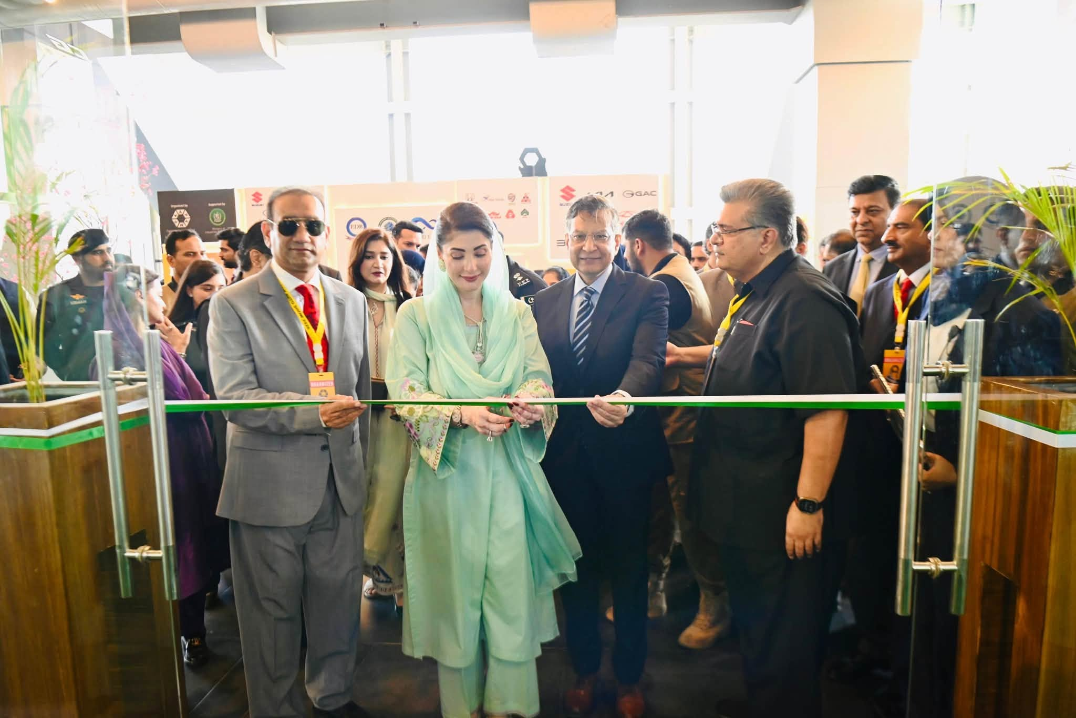
Pakistan Auto Show – 18th Sep 2026, Expo Center Lahore Inaugurated by CM Punjab Ms. Maryam Nawaz
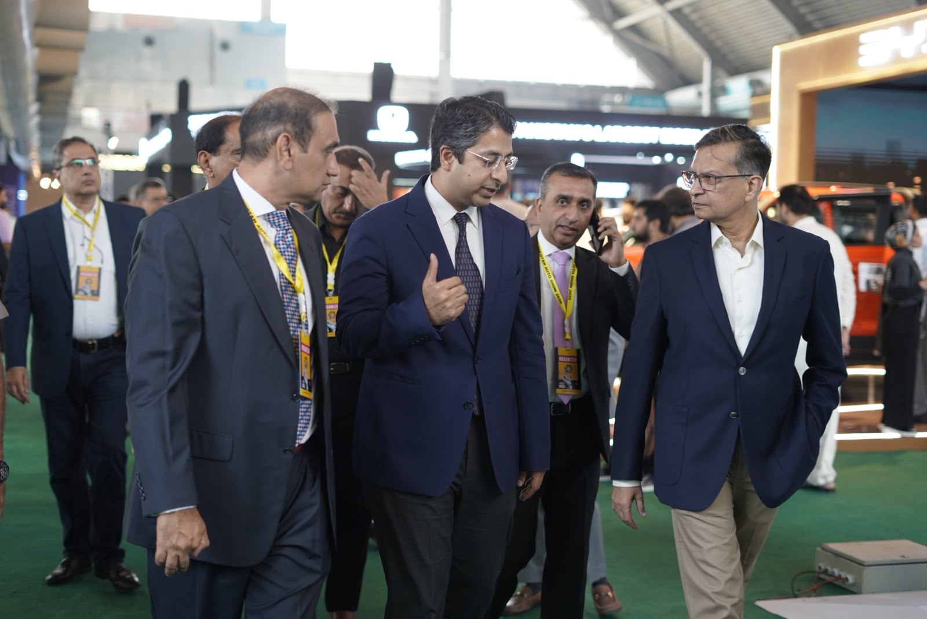
PM Coordinator Rana Ihsaan Afzal Khan attended PAAPAM Symposium 2026

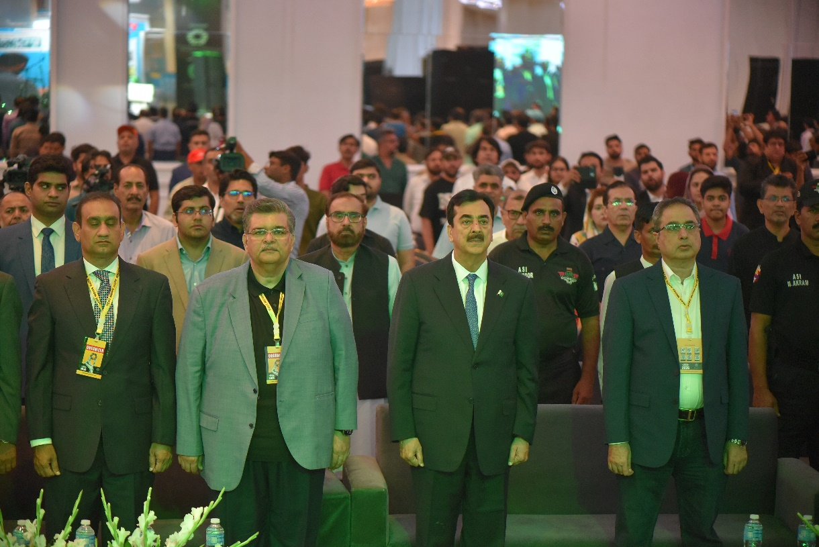
Chairman Senate Syed Yousaf Raza Gillani attended Gala Dinner Night at Nishat Hotel
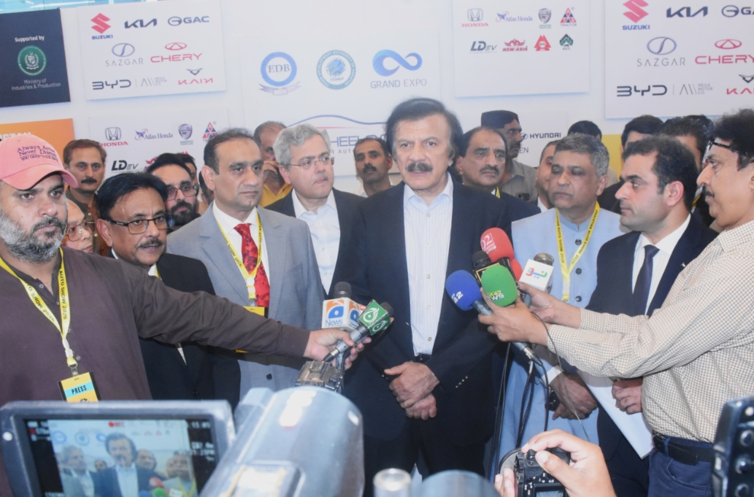
Advisor to PM on Industries & Production Mr. Haroon Akhtar Khan Attended PAPS 2026
Publications & Membership
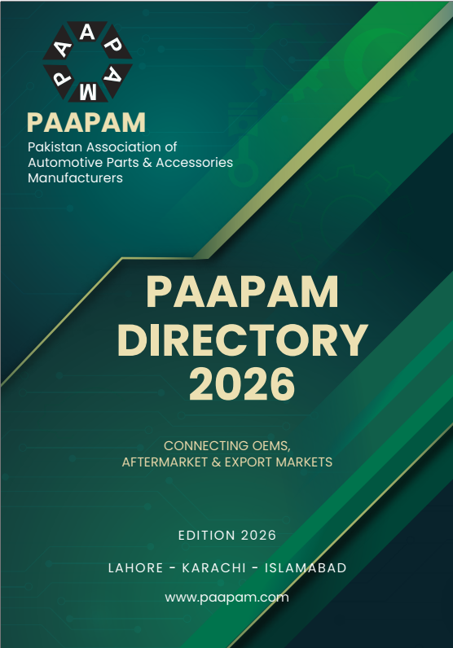
PAAPAM Directory 2026 published under Mr. Razzak Ahmed’s leadership.

International Engagement
Visit of Iranian Consulate General, July 2026
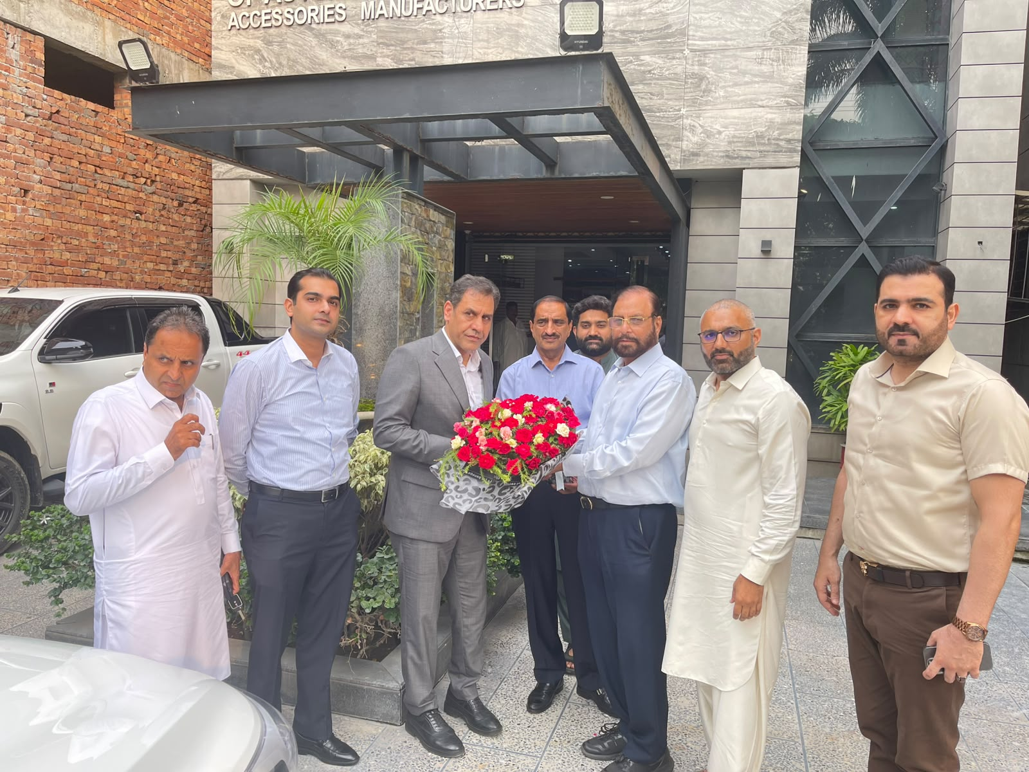
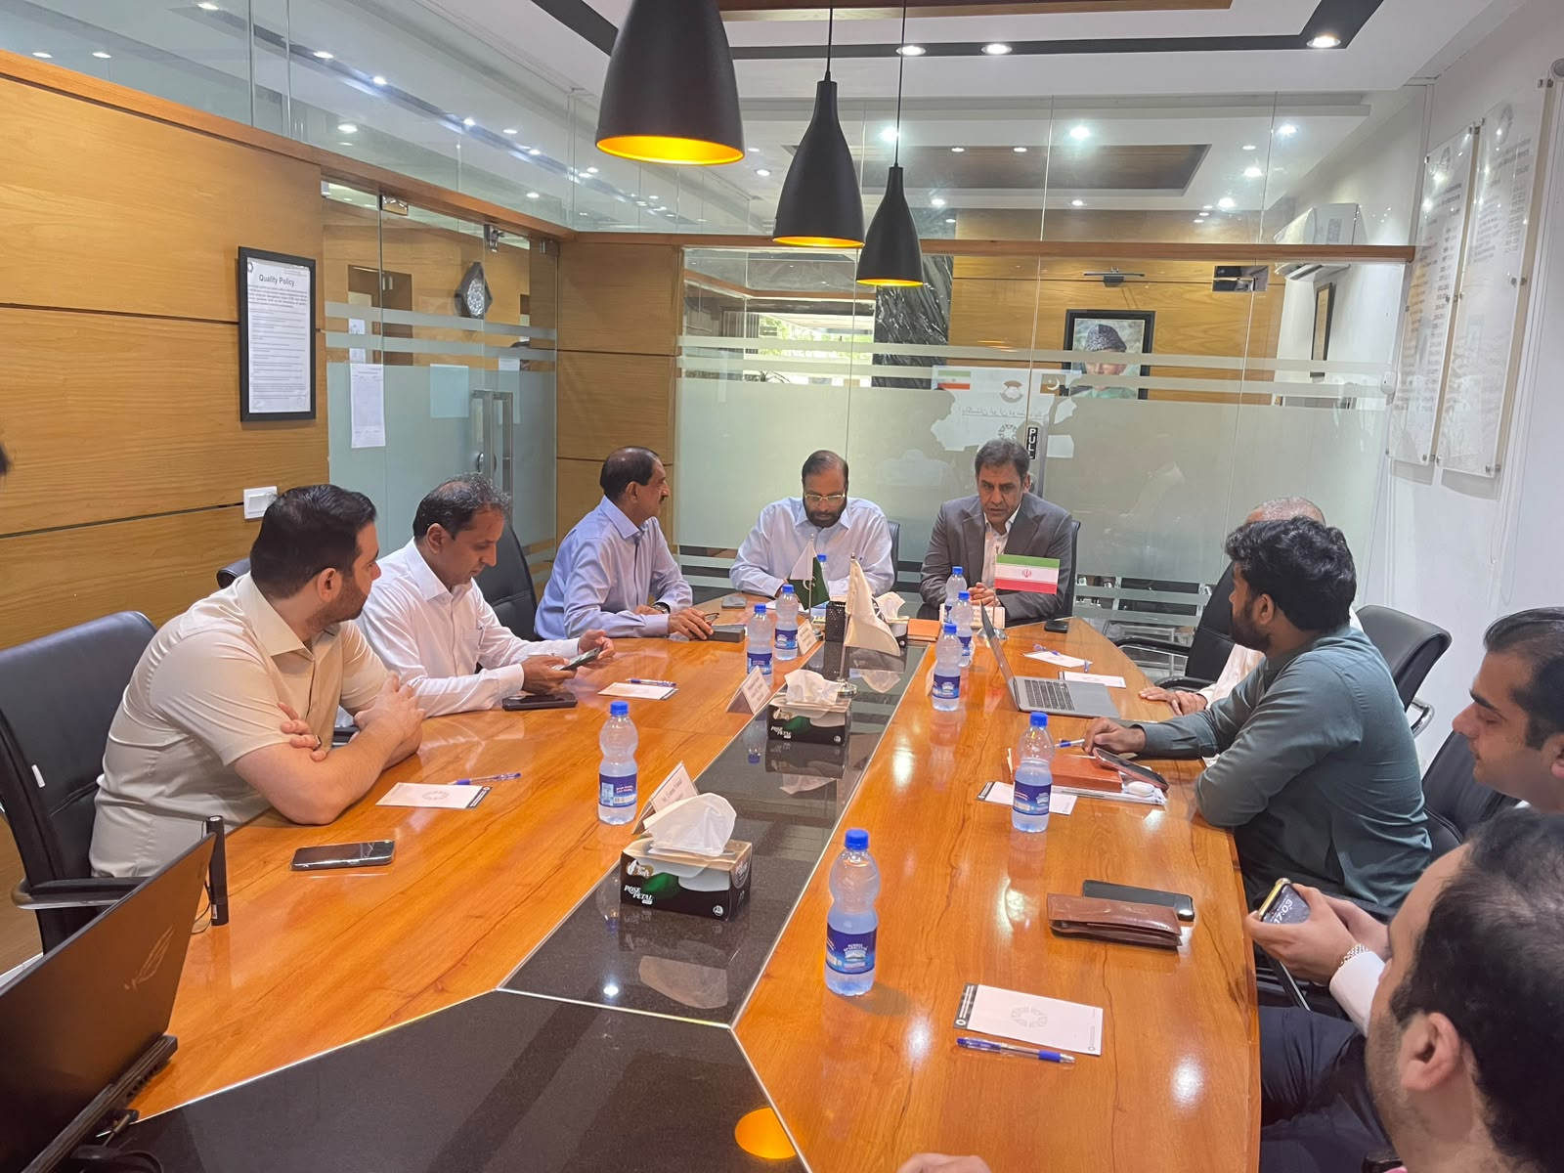

Membership Services
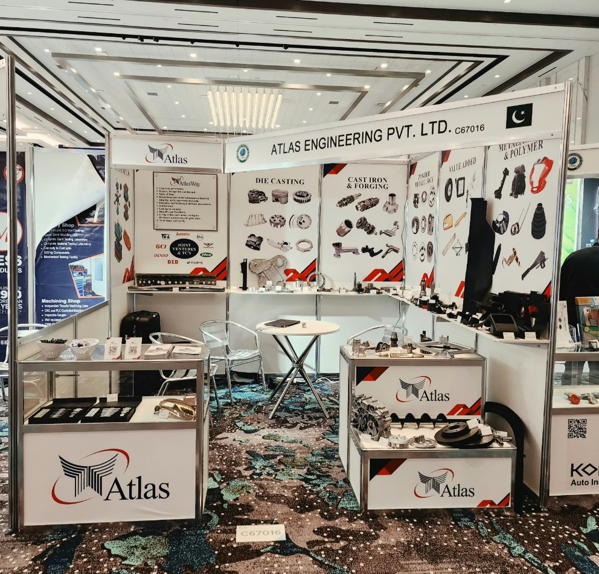
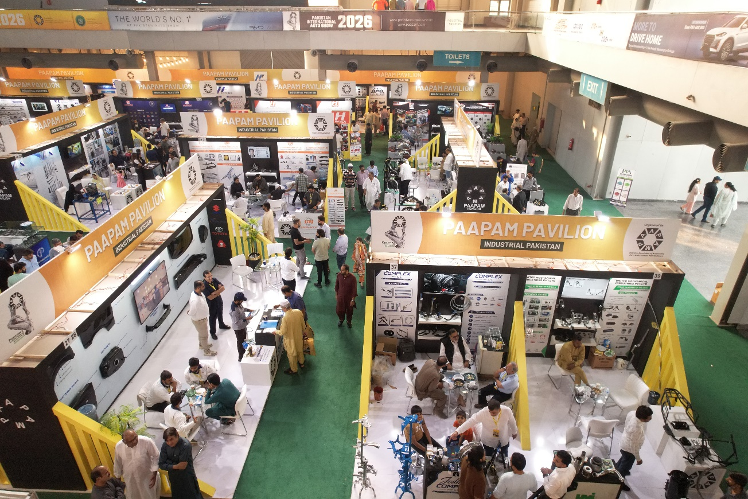
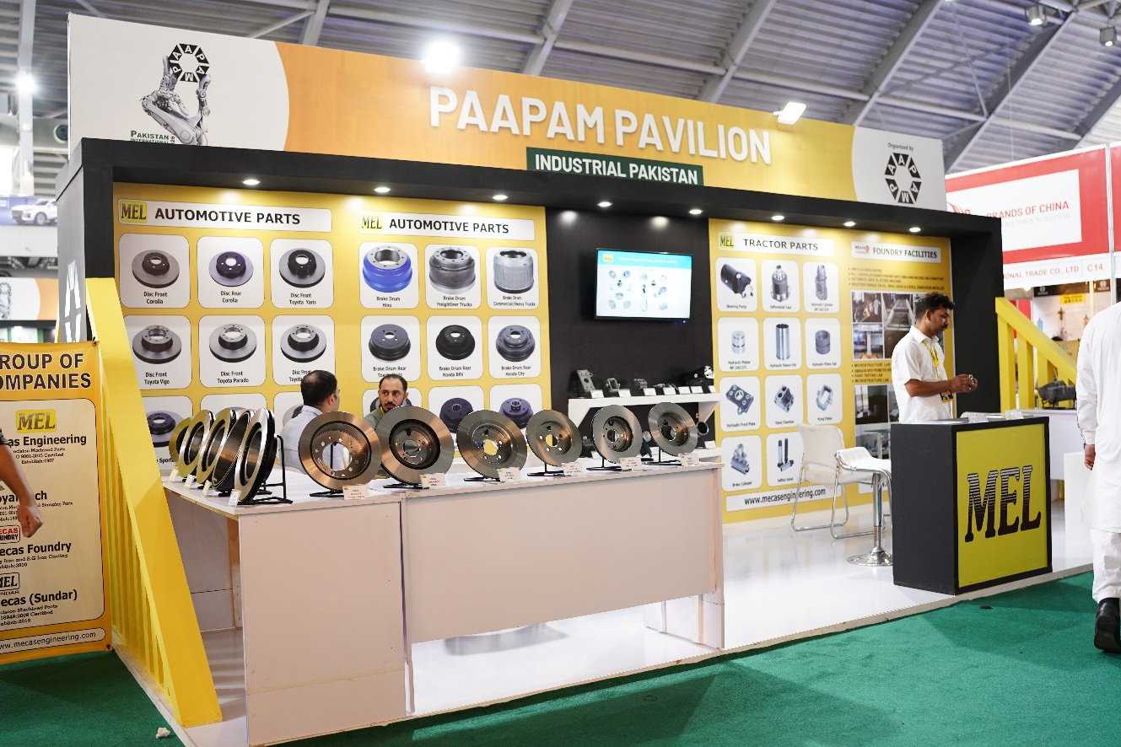
PAAPAM Membership Cards issued on 20th June 2026

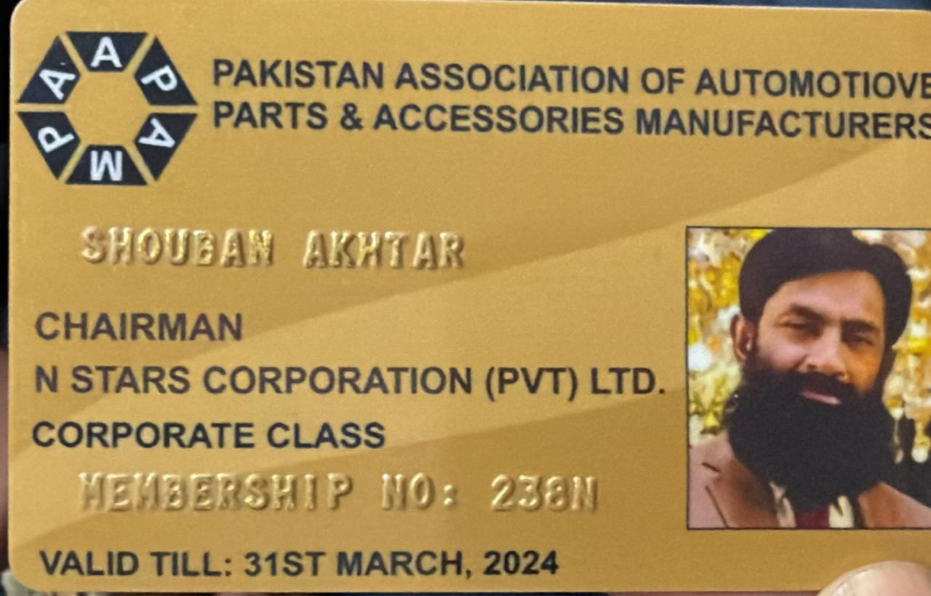

Total New PAAPAM Membership Cases approved = 6

PAAPAM Zonal Office Renovation on 25 Sep 2026
